Name -Muhammad Rafay Ali
Reg_No-UW-24-BS-CS-063
Section-CS 2nd – B

LAB 4

Table

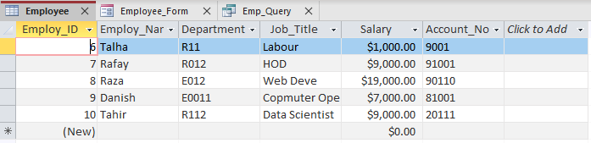

Form

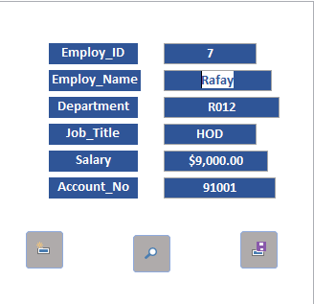
Queries

